Activity No. 6 Introduction to Core APIs
Course Code: CPE 025B | Program: Computer Engineering
Course Title: Software Design 2 | Date Performed: 04/01/26
Section: CPE32S1 | Date Submitted: 04/01/26
Name: Edson Ray San Juan | Instructor: Engr. Neil Matira
1. Objective(s)
This activity aims to introduce the students to the Core APIs used in React Native by building a simple messaging application.
2. Intended Learning Outcomes (ILOs)
After this module, the student should be able to:
- Develop an application using both functional and object-oriented programming in React Native.
- Utilize core APIs to enable functionality within the application.
3. Discussion
Building a messaging app
Our messaging app should enable people to communicate, specifically it must allow the users to:
- Send text messages, images, and maps;
- Choose images from the device camera roll; and
- View images full screen.
For this activity, we will use some of the following APIs to create a simple messaging app.
  - Alert - Displays modal dialog windows for simple user input
  - BackHandler - Controls the back button on Android
  - CameraRoll - Returns images and videos stored on the device
  - Dimensions - Returns the dimensions of the screen
  - Geolocation - Returns the location of the device, and emits events when the location changes
  - Keyboard - Emits events when the keyboard appears or disappears
  - NetInfo - Returns network connectivity information, and emits events when the connectivity changes
  - PixelRatio - Translates from density-independent pixels to density-dependent pixels (more detail on the later)
  - StatusBar - Controls the visibility and color of the status bar
We’ll just be focusing on the UI, so we won’t actually send messages, but we could connect the UI we build to a backend if we wanted to use it in a production app.
4. Materials and Equipment
To properly perform this activity, the student must have:
- Node.js LTS
- Expo
- Emulator / Simulator / Android or iOS Mobile Device
5. Procedure
Initializing the Project
Like we have done with previous activities, we are initializing the project through the following steps:
- Create a new expo app called messaging.
- Navigate into the messaging director afterwards.
Section end, screenshot of progress is required for the output section.
The App
The Application should have the following features, observe the app’s skeleton below:
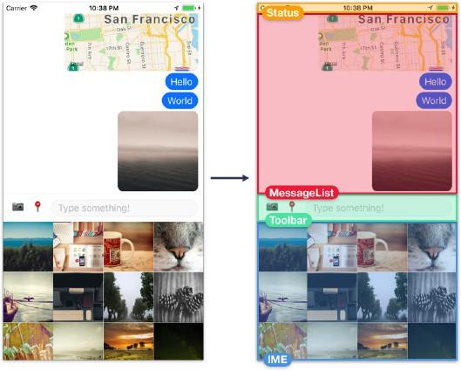
The components that make up the skeleton are as follows:
  - Status - The device generally renders a status bar, the horizontal strip at the top of the screen that shows time, battery life, etc – but in this case, we’ll augment it to show network connectivity more prominently. We’ll create our own component, Status, which renders beneath the device’s status bar.
  - MessageList - This is where we’ll render text messages, images, and maps.
  - Toolbar - This is where the user can switch between sending text, images, or location, and where the input field for typing messages lives.
  - Input Method Editor (IME) - This is where we can render a custom input method, i.e. sending images. We’ll build an image picker component, ImageGrid, and use it here. Note that the keyboard is rendered natively by the operating system, so we will trigger the keyboard to appear and disappear at the right times, but we won’t render it ourselves.
Now, in your App.js, follow the procedures:
- Create the skeleton of the application using functional React Native, like we have done in the previous activity.
- Create the stylesheet objects with the following specifications:
  - container with flex 1 and background color white.
  - content with flex 1 and background color white.
  - inputMethodEditor with flex 1 and background color white.
  - toolbar with borderTopWidth 1, borderTopColor as ‘rgba(0,0,0,0.04)’, and background color white.
- Run the app and preview your progress.
Section end, screenshot of progress is required for the output section.
Network Connectivity Connector
Since we’re building a messaging app, network connectivity is relevant at all times. Let’s let the user know when they’ve lost connectivity by turning the status bar red and displaying a short message.

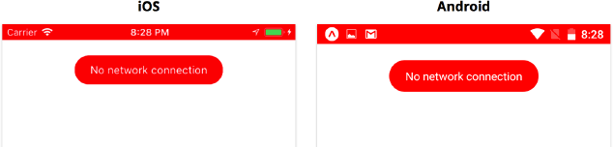

- Open app.json and add the following code to allow our network status bar to use a solid color. Note: You can ignore this if you’re not using Android.
"androidStatusBar": { "barStyle": "dark-content", "backgroundColor": "#FFFFFF"
}

- Create a new status bar component and include imports for Constants from ‘expo’ and StyleSheet from React Native.
- We’ll have two visual states: one where the user is connected to the network, and one where the user is disconnected. We’ll set the color for each state in render, so let’s start with the base style for the status bar:
import { Constants } from 'expo';
import { StyleSheet } from 'react-native';
const statusHeight = (Platform.OS == 'ios' ? Constants.statusBarHeight : 0) const styles = StyleSheet.create({
status: {
zIndex: 1,
height: statusHeight,
}
})

The base style status will give the View its height. The View will have the same height regardless of whether this component is in the connected or disconnected state. We use a zIndex of 1 to indicate that this View should be drawn on top of other content – this will be relevant later, since we’re going to render a ScrollView beneath it.
- We’ll store the network connectivity status in component state as state.info. Network connectivity status can have several different states, but let’s assume for now that if the state.info is "none" then we’re disconnected, and anything else means we’re connected. Let’s try rendering this background View.
import { Constants } from 'expo';
import { NetInfo, Platform, StatusBar, StyleSheet, Text, View } from 'react-native';
import React from 'react';
export default class Status extends React.Component{
state = {
info: null,
};
render() {
const {info} = this.state;
const isConnected = info !== 'none';
const backgroundColor = isConnected ? 'white' : 'red';
if(Platform.OS == 'ios'){
return <View style={[styles.status, {backgroundColor}]}></View>
}
return null; //Temporary!
}
}
const statusHeight = (Platform.OS == 'ios' ? Constants.statusBarHeight : 0) const styles = StyleSheet.create({
status: {
zIndex: 1,
height: statusHeight,
}
})

Notice how we use an array for the View to apply two styles: the status style, and then a style object containing a different background color depending on whether we’re connected to the network or not.
5. Let’s save Status.js and import it from App.js so we can see what we have so far. We can now go ahead and render our new Status component from App:
import Status from './components/Status'; export default function App() {
return (
<View style={styles.container}>
<Status />
// …
</View>

We shouldn’t see anything yet… but to verify that everything is working, you can temporarily set info: 'none' in the state of Status. If possible, you should test this on iOS. You should have a similar result to the image below:

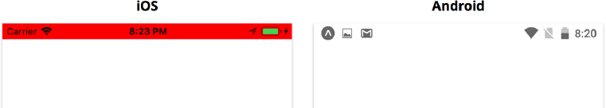

Section end, you must provide a screenshot of your progress so far. Note all of your observations and lessons learned so far.

Using StatusBar
1. Let’s import it from react-native and render it within our View. Place this before the if (Platform.OS === ‘ios’)

const statusBar = (
<StatusBar backgroundColor={backgroundColor}
barStyle={isConnected ? 'dark-content' : 'light-content'} animated={false}
/>
);

Here we set barStyle to dark-content if we’re connected (black text on our white background) and light-content if we’re disconnected (white text on our red background). We set backgroundColor to set the correct background color on Android. We also set animated to false – since we’re not animating the background color on iOS, animating the text color won’t look very good.
Section end, you must provide a screenshot of your progress so far. All of your observations and lessons learned so far have to be noted.
Message Bubble
Since the red status bar alone doesn’t indicate anything about network connectivity, let’s also add a short message in a floating bubble at the top of the screen.

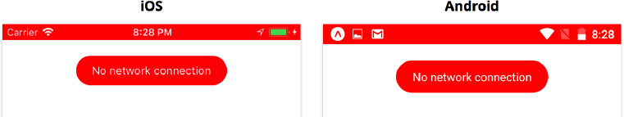

1. Create a new messageContainer so that your code looks similar to what is shown below.

import { Constants } from "expo";
import { NetInfo, StatusBar, StyleSheet, Text, View } from "react-native"; import React from "react";
export default class Status extends React.Component {
// ...
render() {
const { info } = this.state;
const isConnected = info !== "none";
const backgroundColor = isConnected ? "white" : "red"; const statusBar = (
<StatusBar backgroundColor={backgroundColor}
barStyle={isConnected ? "dark-content" : "light-content"} animated={false}
/>
);
const messageContainer = (
<View style={styles.messageContainer} pointerEvents={"none"}>
{statusBar}
{!isConnected && (
<View style={styles.bubble}>
<Text style={styles.text}>No network connection</Text>
</View>
)}
</View>
);
if (Platform.OS === "ios") { return (
<View style={[styles.status, { backgroundColor }]}>
{messageContainer}
</View>
);
}
return messageContainer;
}
}

- Create StyleSheet objects so that you have the following specifications:
  - messageContainer has a zIndex of 1, position absolution, top value statusHeight + 20, right and left as 0, height as 80, and alignItems to center.
  - bubble with paddingHorizontal value of 20, paddingVertical value of 10, borderRadius value of 20, and backgroundColor value of ‘red’.
  - text with color white.
Screenshot your current progress, your output must be similar to the image below. Is it similar? Did you encounter any challenges answering this activity?

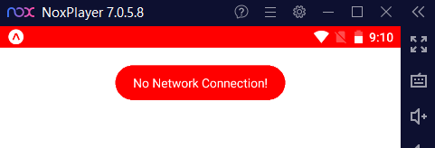

6. Output
Your output for this activity contributes toward the achievement of ILO1: Develop an application using both functional and object-oriented programming in React Native.

The App
Now, in your App.js, follow the procedures:
- Create the skeleton of the application using functional React Native, like we have done in the previous activity.
- DONE
- Create the stylesheet objects with the following specifications:
  - container with flex 1 and background color white.
  - content with flex 1 and background color white.
  - inputMethodEditor with flex 1 and background color white.
  - toolbar with borderTopWidth 1, borderTopColor as ‘rgba(0,0,0,0.04)’, and background color white.
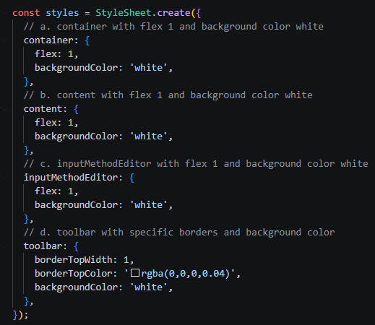

3. Run the app and preview your progress.

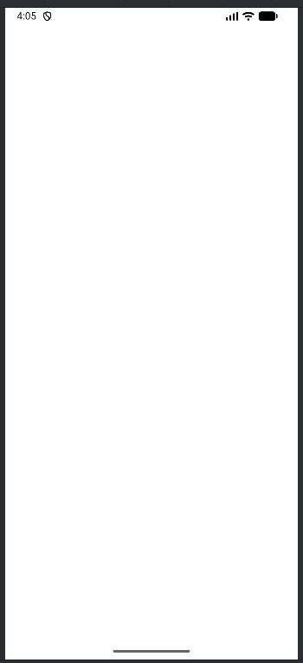
- Observation:
  - The app is designed using a "layered" architecture. The Status component sits at the top level of the App.js container, ensuring that network alerts always stay visible regardless of what is happening in the MessageList or Toolbar.
  - The use of a red "No network connection" bubble is a standard UX pattern. By setting pointerEvents="none", the app remains functional; the user can still scroll through old messages even while the warning bubble is visible, which is a key trait of professional messaging apps.
  - I observed that app.json settings (like androidStatusBar) are critical because they define how the hardware interacts with the software before the first line of Javascript even runs.

Network Connectivity Connector
- MY OUTPUT
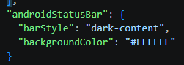
- 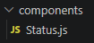

import Constants from 'expo-constants';
import { NetInfo, Platform, StatusBar, StyleSheet, Text, View } from 'react-native';
import React from 'react';

export default class Status extends React.Component {
state = {
info: null,
};

render() {
const { info } = this.state;

const isConnected = info !== 'none';
const backgroundColor = isConnected ? 'white' : 'red';

if (Platform.OS === 'ios') {
return <View style={[styles.status, { backgroundColor }]}></View>;
}

return null;
}
}

const statusHeight = Platform.OS === 'ios' ? Constants.statusBarHeight : 0;

const styles = StyleSheet.create({
status: {
zIndex: 1,
height: statusHeight,
},
});

- (3 and 4) CODE

// Status.js
import Constants from 'expo-constants';
import { NetInfo, Platform, StatusBar, StyleSheet, Text, View } from 'react-native';
import React from 'react';

export default class Status extends React.Component {
state = {
info: 'none',
};

render() {
const { info } = this.state;
const isConnected = info !== 'none';
const backgroundColor = isConnected ? 'white' : 'red';

if (Platform.OS === 'ios') {
return <View style={[styles.status, { backgroundColor }]}></View>;
}

return null;
}
}

const statusHeight = Platform.OS === 'ios' ? Constants.statusBarHeight : 0;

const styles = StyleSheet.create({
status: {
zIndex: 1,
height: statusHeight,
},
});

5. OUTPUT
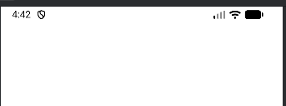
- Lessons Learned:
  - I learned that the StatusBar API in React Native acts as a "remote control" for the system tray on Android, whereas on iOS, we often have to build a physical View to act as the background.
  - Using array-based styling (e.g., style={[styles.status, {backgroundColor}]}) is a powerful way to toggle UI states (Connected vs. Disconnected) without duplicating code.
  - Initializing state.info as null and then testing with 'none' taught me how to simulate different environment conditions (like losing Wi-Fi) during the development phase.
Message Bubble
- CODE

import React from 'react';
import { Constants } from 'expo';
import { Platform, StatusBar, StyleSheet, Text, View } from 'react-native';

export default class Status extends React.Component {
state = {
info: 'none',
};

render() {
const { info } = this.state;
const isConnected = info !== 'none';
const backgroundColor = isConnected ? 'white' : 'red';

const statusBar = (
<StatusBar
backgroundColor={backgroundColor}
barStyle={isConnected ? 'dark-content' : 'light-content'}
animated={false}
/>
);

const messageContainer = (
<View style={styles.messageContainer} pointerEvents={'none'}>
{statusBar}
{!isConnected && (
<View style={styles.bubble}>
<Text style={styles.text}>No network connection</Text>
</View>
)}
</View>
);

if (Platform.OS === 'ios') {
return (
<View style={[styles.status, { backgroundColor }]}>
{messageContainer}
</View>
);
}

return (
<View style={[styles.status, { backgroundColor }]}>
{messageContainer}
</View>
);
}
}

const statusHeight = (Platform.OS === 'ios' ? Constants.statusBarHeight : Constants.statusBarHeight);

const styles = StyleSheet.create({
status: {
zIndex: 1,
height: statusHeight,
},
messageContainer: {
zIndex: 1,
position: 'absolute',
top: statusHeight + 20,
right: 0,
left: 0,
height: 80,
alignItems: 'center',
},
bubble: {
paddingHorizontal: 20,
paddingVertical: 10,
borderRadius: 20,
backgroundColor: 'red',
},
text: {
color: 'white',
},
});

- Create StyleSheet objects so that you have the following specifications:
  - messageContainer has a zIndex of 1, position absolution, top value statusHeight + 20, right and left as 0, height as 80, and alignItems to center.
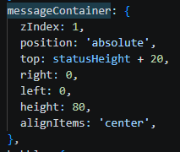
  - bubble with paddingHorizontal value of 20, paddingVertical value of 10, borderRadius value of 20, and backgroundColor value of ‘red’.
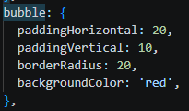
  - text with color white.
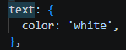
- Is it similar?
  - The implementation is similar in logic but different in visual layers. Both platforms use the messageContainer to absolute-position the bubble. However, the visual result on Android often lacks the "red strip" seen in the iOS manual unless you manually force the statusHeight and View background.
- Challenges Encountered:
  - Android Status Bar Height: The biggest challenge was that Constants.statusBarHeight on Android does not automatically "push" content down like it does on iOS. If the height is set to 0 or handled incorrectly, the red bubble can overlap the system clock/battery icons.
  - Z-Index & Positioning: Ensuring the bubble floats over other content but under the status bar icons required careful use of zIndex and pointerEvents="none".

- MY OUTPUT
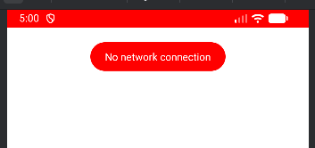

// App.js
import React from 'react';
import { StyleSheet, View } from 'react-native';
import Status from './components/Status';

export default function App() {
return (
<View style={styles.container}>
{/* Augmented Status Bar Component */}
<Status />

{/* Main message display area */}
<View style={styles.content}>
{/* MessageList will be implemented here */}
</View>

{/* Input area for text, images, and location */}
<View style={styles.toolbar}>
{/* Toolbar UI will be implemented here */}
</View>

{/* Custom Input Method Editor (e.g., ImageGrid) */}
<View style={styles.inputMethodEditor}>
{/* IME/ImageGrid will be implemented here */}
</View>
</View>
);
}

const styles = StyleSheet.create({
container: {
flex: 1,
backgroundColor: 'white',
},
content: {
flex: 1,
backgroundColor: 'white',
},
inputMethodEditor: {
flex: 1,
backgroundColor: 'white',
},
toolbar: {
borderTopWidth: 1,
borderTopColor: 'rgba(0,0,0,0.04)',
backgroundColor: 'white',
},
});

// Status.js
import React from 'react';
import Constants from 'expo-constants';
import { Platform, StatusBar, StyleSheet, Text, View } from 'react-native';

export default class Status extends React.Component {
state = {
info: 'none',
};

render() {
const { info } = this.state;
const isConnected = info !== 'none';
const backgroundColor = isConnected ? 'white' : 'red';

const statusBar = (
<StatusBar
backgroundColor={backgroundColor}
barStyle={isConnected ? 'dark-content' : 'light-content'}
animated={false}
/>
);

const messageContainer = (
<View style={styles.messageContainer} pointerEvents={'none'}>
{statusBar}
{!isConnected && (
<View style={styles.bubble}>
<Text style={styles.text}>No network connection</Text>
</View>
)}
</View>
);

return (
<View style={[styles.status, { backgroundColor }]}>
{messageContainer}
</View>
);
}
}

const statusHeight = Constants.statusBarHeight;

const styles = StyleSheet.create({
status: {
zIndex: 1,
height: statusHeight,
},
messageContainer: {
zIndex: 1,
position: 'absolute',
top: statusHeight + 20,
right: 0,
left: 0,
height: 80,
alignItems: 'center',
},
bubble: {
paddingHorizontal: 20,
paddingVertical: 10,
borderRadius: 20,
backgroundColor: 'red',
},
text: {
color: 'white',
},
});


7. Supplementary Activity
ILO2: Utilize core APIs to enable functionality within the application.
We have info in state, and we have logic to switch between showing a connected and disconnected UI in our render method. Now we need to update this state whenever network connectivity changes.
We can do this using the NetInfo APIs. The NetInfo APIs are a good example of React Native core APIs: these provide a uniform interface to the lower level native APIs on iOS and Android. React Native is essentially providing JavaScript bindings and smoothing out platform differences for us.
We can call NetInfo.getConnectionInfo() to get the network connectivity status. NetInfo.getConnectionInfo() returns a promise which resolves to a string. If the device is connected, the string value will be 'wifi' or 'cellular' If the device isn’t connected, the promise will still resolve, but with the value 'none'.
If we wanted to update our UI when the network connection changes, we could continuously poll NetInfo.getConnectionInfo() to get the network status – but this would be inefficient. Instead, we can add an event listener to NetInfo. NetInfo provides the method addEventListener, which we can call with a callback function, which it will invoke each time the network status changes.
Here’s an example of using NetInfo.addEventListener:

const subscription = NetInfo.addEventListener('connectionChange', (status) => { console.log('Network status changed', status)
});

This example would log a new status each time the network connectivity changes. We can call subscription.remove() when we want to stop listening for changes – most of the time, we’ll do this when our component unmounts. For our app, we’ll use both NetInfo.getConnectionInfo and NetInfo.addEventListener. First we’ll call NetInfo.getConnectionInfo when the Status component mounts to get the initial network connectivity. Then we’ll use NetInfo.addEventListener to update our UI when a change occurs.
Tasks:
- Modify Status.js so that you can use a Core API (such as NetInfo) to retrieve connection information.

// Status.js
import React from 'react';
import Constants from 'expo-constants';
import { Platform, StatusBar, StyleSheet, Text, View } from 'react-native';
import NetInfo from '@react-native-community/netinfo';

export default class Status extends React.Component {
state = {
info: null,
};

async componentDidMount() {
const state = await NetInfo.fetch();
this.setState({ info: state.type });

this.subscription = NetInfo.addEventListener(state => {
this.handleConnectivityChange(state.type);
});
}

componentWillUnmount() {
if (this.subscription) {
this.subscription();
}
}

handleConnectivityChange = (connectionType) => {
this.setState({ info: connectionType });
};

render() {
const { info } = this.state;
const isConnected = info !== 'none' && info !== 'unknown';
const backgroundColor = isConnected ? 'white' : 'red';

const statusBar = (
<StatusBar
backgroundColor={backgroundColor}
barStyle={isConnected ? 'dark-content' : 'light-content'}
animated={false}
/>
);

const messageContainer = (
<View style={styles.messageContainer} pointerEvents={'none'}>
{statusBar}
{!isConnected && (
<View style={styles.bubble}>
<Text style={styles.text}>No network connection</Text>
</View>
)}
</View>
);

return (
<View style={[styles.status, { backgroundColor }]}>
{messageContainer}
</View>
);
}
}

const statusHeight = Constants.statusBarHeight;

const styles = StyleSheet.create({
status: {
zIndex: 1,
height: statusHeight,
},
messageContainer: {
zIndex: 1,
position: 'absolute',
top: statusHeight + 20,
right: 0,
left: 0,
height: 80,
alignItems: 'center',
},
bubble: {
paddingHorizontal: 20,
paddingVertical: 10,
borderRadius: 20,
backgroundColor: 'red',
},
text: {
color: 'white',
},
});


- Test the connection: It must not display any message when there is a connection and vice-versa.

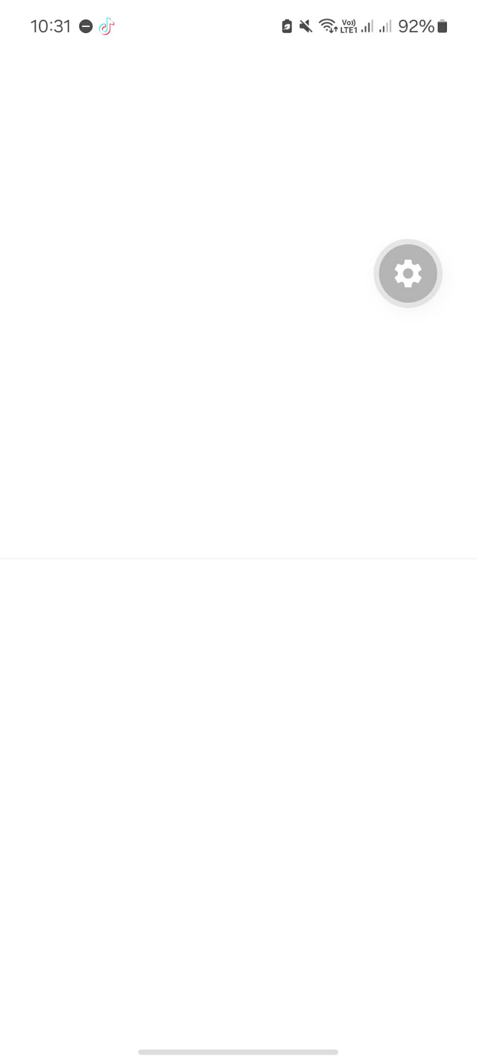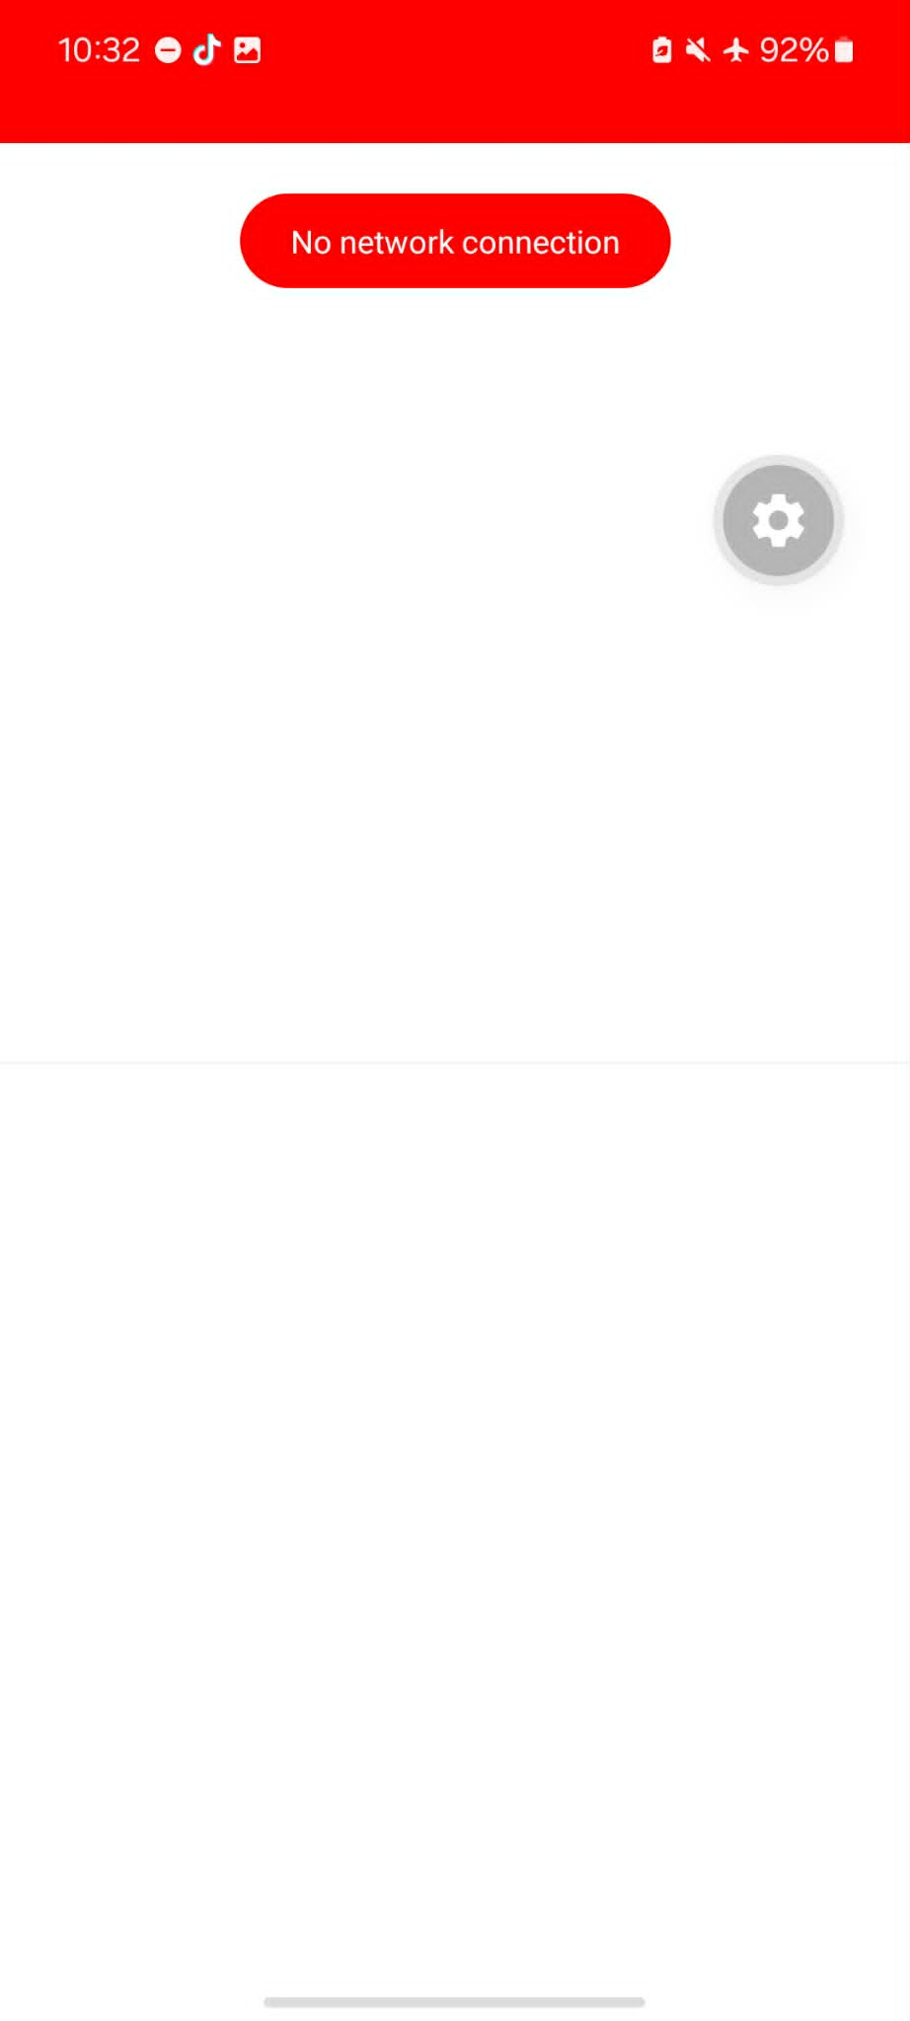

- Initial Fetch (componentDidMount) - Upon mounting, the component performs an asynchronous call using NetInfo.fetch() to capture the current connection type (e.g., 'wifi', 'cellular', or 'none'). This ensures the UI is accurate the moment the app opens.
- Event Subscription - A listener is established using NetInfo.addEventListener, which triggers the handleConnectivityChange function whenever the device transitions between network states. This allows the app to react instantly such as when Airplane Mode is toggled without requiring a manual refresh.
- Conditional Rendering Logic - The render() method calculates a boolean isConnected based on whether the state info is equal to 'none'.
  - When Connected: The isConnected constant is true, resulting in a white background and a dark-content status bar. The "No network connection" bubble is logically excluded from the UI.
  - When Disconnected: The isConnected constant evaluates to false. This automatically triggers a "UI switch" where the background turns red and the bubble component is rendered to notify the user.
- Resource Cleanup (componentWillUnmount) - To ensure the application remains performant and leak-free, the subscription is invoked as a function to unsubscribe the listener when the Status component is destroyed.
Hint: Check documentation for NetInfo API to verify functions associated and check sample code.

// App.js
import React from 'react';
import { StyleSheet, View } from 'react-native';
import Status from './components/Status';

export default function App() {
return (
<View style={styles.container}>
{/* Augmented Status Bar Component */}
<Status />

{/* Main message display area */}
<View style={styles.content}>
{/* MessageList will be implemented here */}
</View>

{/* Input area for text, images, and location */}
<View style={styles.toolbar}>
{/* Toolbar UI will be implemented here */}
</View>

{/* Custom Input Method Editor (e.g., ImageGrid) */}
<View style={styles.inputMethodEditor}>
{/* IME/ImageGrid will be implemented here */}
</View>
</View>
);
}

const styles = StyleSheet.create({
container: {
flex: 1,
backgroundColor: 'white',
},
content: {
flex: 1,
backgroundColor: 'white',
},
inputMethodEditor: {
flex: 1,
backgroundColor: 'white',
},
toolbar: {
borderTopWidth: 1,
borderTopColor: 'rgba(0,0,0,0.04)',
backgroundColor: 'white',
},
});

// Status.js
import React from 'react';
import Constants from 'expo-constants';
import { Platform, StatusBar, StyleSheet, Text, View } from 'react-native';
import NetInfo from '@react-native-community/netinfo';

export default class Status extends React.Component {
state = {
info: null,
};

async componentDidMount() {
const state = await NetInfo.fetch();
this.setState({ info: state.type });

this.subscription = NetInfo.addEventListener(state => {
this.handleConnectivityChange(state.type);
});
}

componentWillUnmount() {
if (this.subscription) {
this.subscription();
}
}

handleConnectivityChange = (connectionType) => {
this.setState({ info: connectionType });
};

render() {
const { info } = this.state;
const isConnected = info !== 'none' && info !== 'unknown';
const backgroundColor = isConnected ? 'white' : 'red';

const statusBar = (
<StatusBar
backgroundColor={backgroundColor}
barStyle={isConnected ? 'dark-content' : 'light-content'}
animated={false}
/>
);

const messageContainer = (
<View style={styles.messageContainer} pointerEvents={'none'}>
{statusBar}
{!isConnected && (
<View style={styles.bubble}>
<Text style={styles.text}>No network connection</Text>
</View>
)}
</View>
);

return (
<View style={[styles.status, { backgroundColor }]}>
{messageContainer}
</View>
);
}
}

const statusHeight = Constants.statusBarHeight;

const styles = StyleSheet.create({
status: {
zIndex: 1,
height: statusHeight,
},
messageContainer: {
zIndex: 1,
position: 'absolute',
top: statusHeight + 20,
right: 0,
left: 0,
height: 80,
alignItems: 'center',
},
bubble: {
paddingHorizontal: 20,
paddingVertical: 10,
borderRadius: 20,
backgroundColor: 'red',
},
text: {
color: 'white',
},
});


8. Conclusion
- A concise summary of the activity performed.
In this activity I successfully integrated the NetInfo API into a React Native application to monitor and respond to real-time network changes. By utilizing componentDidMount for initial status detection and an event listener for live updates, I developed a dynamic UI that toggles between a standard white status bar and a red "No Connection" alert.

- Your personal conclusions / reflections.
In conclusion this activity highlighted how critical immediate visual feedback is for maintaining a professional user experience in mobile development. I realized that handling offline states gracefully is not just a feature, but a necessity to prevent user frustration when network-dependent actions fail.

- An overview of the lessons you learned from this module.
The module provided a practical understanding of React Native’s Core APIs and how to bridge level device hardware and the application's state.I learned how to implement asynchronous methods like fetch() alongside event-driven subscriptions to keep the interface synchronized with the external environment. Overall, I gained experience in conditional rendering and utilizing Constants.statusBarHeight to ensure a consistent layout across different mobile hardware and operating systems.
9. Assessment Rubric
